
25 July 2014 The Weekly Bulletin of Rotary Club of Kathmandu Mid-Town bc-04/7.014
Rotary Club of Kathmandu Mid-Town
Breakfast Chatter


District: 3292 Web: www.rotarymidtown.org.np Club Id: 26776

JULY 2014

Celebrating
25 Years in Rotary


Friday, 18 July :
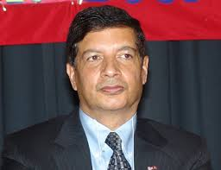
Dr Shankar Sharma, an economist-turned-diplomat, who served as Nepal’s
ambassador to the USA for 4 years, re-joined the Club recently and gave a brief talk as the in-house speaker to share his memorable experiences during his tenure as Ambassador.
While answering to some of the queries he elaborated how tough and time-consuming it
was to get the ball rolling even on one agenda.

Weekly Meetings and Programs :
Date | Program/Speaker | Program/Topics of Presentation
25 Jul 2014 | Ms Poonam Rana | Witch practice in Nepal

Friday, 25 July :
Ms Poonam Rana will be our guest speaker. She will be talking on ‘witch practice
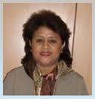
in Nepal.’ Superstitious practices and belief have dominated the socio-cultural
lives of the people from time immemorial. Witch-hunting, shamanic practices,
para-normal doctors and healers, divine and God-man claims are the common-
place phenomena not only in the illiterate and ignorant rural community of
Nepal but also in the urban centers. The superstitious practices of various kinds
have dehumanized the people at large and their community, they have taken
the lives of many innocent and ignorant individuals. Humanist Association of
Nepal (HUMAN) conducted case studies and compiled information on alleged
witchcraft practices in 45 districts of Nepal. The case studies revealed how
severely superstitious and the irrational practices have victimized the innocent and credulous people, particularly women in different parts of the country. More on the topics we hear from our guest speaker.

Public Image :
Every organization has a story to tell, a story that invites people to join them, a story that tells the world what the organization is all about. Rotary has a story also. We have had a story for 109 years - but our problem has been that we have not shared Rotary’s story.If you were asked, “What is Rotary?” or “What makes Rotary unique?” how would you respond? If we want to increase our membership and make Rotary a more viable, appealing organization, we need to start thinking about how to tell the Rotary story, and how to tell it in a short, compelling,and meaningful way. Rotary has a rich story, and that story is what brought you and me into Rotary.
In the business world, there is something known as an elevator speech. If you are on an elevator and someone asks, “What is that pin you are wearing?” and you say, “Rotary,” then the next question is, “What is Rotary?” You should be able to respond quickly. You should be able to state in such a compelling way what Rotary is that the individual will want to get off on your floor rather than his, to learn more about Rotary.
As a district governor, it will be your job to help your district and club Rotarians create their own elevator speech. Teach them to use terms such as:
• Rotary connects people.
• Rotary takes action and never gives up.
• Rotary inspires people to want to make a difference.
Public image is all about telling the Rotary story.
1. Tell the story of what we have done and are doing to eradicate polio in the world.
Last year, 1.3 billion doses of the polio vaccine were given to 429 million children in 70 countries, at a cost of $170 million. And 820,000 doors were knocked on. Who knocked on those doors? Who saved those children from being disabled all their lives? That is a Rotary story that people can relate to.
2. Tell them what Rotarians are doing to address hunger, health, water, and literacy issues. State facts:
• 13 million people starve to death every year.
• 1 billion people go to bed hungry every night. If we look specifically at health:
• Again, 1 billion people have no access to health care.
• WHO (World Health Organization) states that two-thirds of the little children who die yearly could be saved through simple and inexpensive technologies, if they were available.
• Every 60 seconds, a child goes blind in the world because of no medical care.
If we look at the water issue:
• Today, or on any given day, half the people in developing countries are sick because they drank contaminated water.
• 1.1 billion people do not have access to safe, clean water.
And look at literacy:
• 26 percent of the world’s population cannot read, write, sign their name legally, or do simple math.
• Education is the path out of poverty and is the first step to preventing and eliminating most of the world’s problems.
Those are all Rotary stories, and simply stated, Rotarians are addressing these tragic situations in local communities and in locations all over the world.
Rotarians, tell them where Rotary goes:
• The hungry are fed.
• The homeless secure shelter.
• The sick are given medical care.
• The naked are clothed.
• The children are immunized.
• The illiterate are given pportunities to learn how to read, write, and do math.
• And thousands upon thousands are given clean water to drink, to use in cooking food, to bathe, and to use in washing their clothes.
So,these are Rotary stories. Rotarians are engaged in changing lives. And when we do, we give value to lives where there seems to be none. We give hope to situations where none exists. These stories are the face of Rotary’s public image: Rotarians Doing Good in the World and making a difference! And it is your job and mine to tell the Rotary story — tell it in a way that is short, compelling, and impacts personally with people.
Source: Anne L. Matthews, RI Vice President

On Lighter Side :
Charlie Chaplin meets Albert Einstein
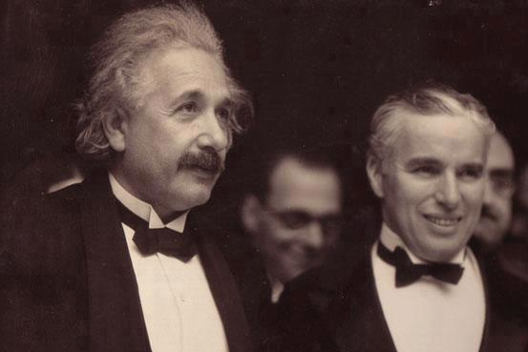

Albert Einstein says “what I admire most about your art is its universality. You do not say a word, and yet ... the world understands you.”
“It's true,” replies Chaplin. “But your fame is even greater: the world admires you, when nobody understands you !”

Great quotes :
There is a wonderful mythical law of nature that three things that we crave for most in life –
happiness, freedom, and peace of mind, are always attained by giving them to someone else.
Let us all share our happiness!!

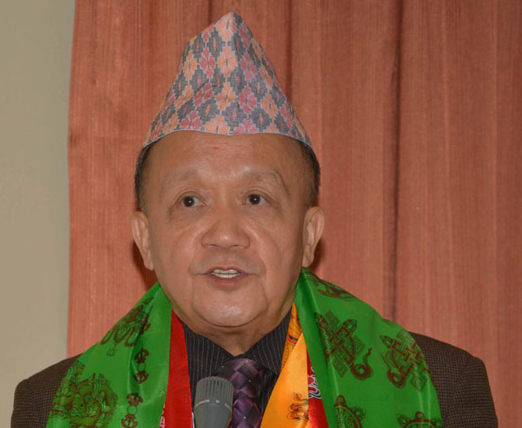

How you Light Up Rotary — how you light your own candle — is up to you. You know where
you are strong. You know what your community needs, and you know how you can help.

RI President GARY C.K. HUANG

Please send information on club activities, progress reviews on service projects, relevant photos etc to:
BC Editor: RR Shrestha email: rryesrr@gmail.com

25 July 2014 The Weekly Bulletin of Rotary Club of Kathmandu Mid-Town bc-04/7.014

